Player Development Football Camp 2022
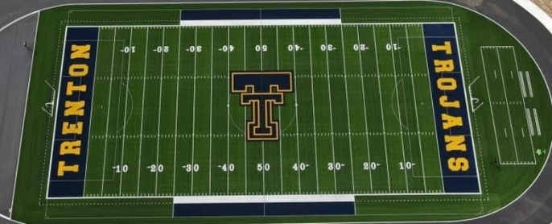
USMC Recruiting Phone: (248) 631-8693
Email: isaac.holley@marines.usmc.mil
Dates: July 18th – July 21st
Cost: Donation of 10 dollars to the
*Make checks payable to Trenton Public Schools. Proceeds will go to Fuel Up with Milk School Challenge:
Open to all students grades 6th to 12th fall of 2022
Deadline: July 14th *Please send to
Coach Reggie Glon
Trenton High School
2601 Charlton Rd, Trenton, MI 48183
Email glonr@trentonschools.com
Partners: United Dairy Industry of Michigan
USMC Recruiting Office (Wyandotte)
Schedule: * If you cannot attend the entire camp you may attend portions we just need to know.
Time Monday (July 18) Tuesday (July 19) Wednesday (July 20) Thursday (July 21)
9 am --------------------------------- Camp Welcome and Being a REAL Man presentations ---------------------------------------
9:30 am -------------------------------------------------- Session 1 on the field -----------------------------------------------------------------
12:00 noon -------------------------------------------------- Lunch on your own --------------------------------------------------------------------
1:30 pm Sports Nutrition & Rest lectures USMC Leadership and Team Cohesion
2:30 pm ----------------------------------- Sports Performance & Conditioning program -------------------------------------------------
3:30 pm ---------------------------------- Break (Sponsored by Michigan Dairy Association) --------------------------------------------
4:00 pm ---------------------------------------------- College Recruiting Process ---------------------------------------------------------------
4:30 pm -------------------------------------------------- Session 2 on the field -----------------------------------------------------------------
5:30 pm ---------------------------------------------------- 7 on 7 Tournaments ----------------------------------------------------------------
7:00 pm ----------------------------------------------------- Camp Concludes -------------------------------------------------------------------
--------------------------------------------------------------------------------------------------------------------------------------------------
Return with Waiver (Page 2)
Name _______________________ School __________________ Grade _______
Address _______________________ Email ______________________________________
Phone (___) __________________ Emergency Phone (___)________________
Position _________

